PERSONAL DETAILS
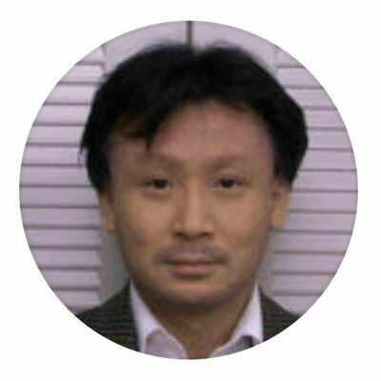  Paste your photo | Full Name | Hiroshi Sakiyama
 | Gender | Male
 | Designation | Professor (full)
 | Department | Faculty of Science
 | Institution/Organization | Yamagata University
 | Qualification | Doctor of Science
 | Area of Specialization | Chemistry
 | Sub Division | Coordination Chemistry
 | DOB | March 3rd 1966
 | DOJ
 | Total Experience
 | Mobile Number
 | Email | saki@sci.kj.yamagata-u.ac.jp
About your Education, Experience and Academic achievements (200 words)

Graduated Kyushu University (chemistry) in 1988
Took Doctor of Science degree from Kyushu University (chemistry) in 1993
Assistant professor of Kyushu University 1993-1995
Associate professor of Yamagata University 1995-2019
Professor (full) of Yamagata University 2019-present

Studied functional model of manganese catalase, functional model of aminopeptidase, magnetic analysis of multinuclear octahedral high-spin cobalt(II) complexes, magnetic analysis of metal complexes with T ground terms, etc.

RESEARCH, INNOVATIONS AND EXTENSION
Question | Nos. | Question | Nos.
No. of Research Project Completed and On Going |  | Citation index in Scopus/ Web of Science or PubMed/ Indian Citation Index
No. of Consultancy and Industries Sponsored Projects |  | No. of Books Published with ISBN  (Text, Reference, Chapters and Conference Proceedings)
Total cost of the all Projects in USD/INR |  | No. of Patent Published and Under Process
No. of Journals Published in SCI and SCIE index |  | No. of Editorial Appointments in Journals/Conferences (Editor, Reviewer and Member)
No. of Journals Published in Scopus, Web of Science and PubMed index | 192 | No of Countries Visited for research activities | 8
No. of Journals Published in Other index |  | No. of Research scholar Graduated
No. of Conference Presentation |  | No. of Research scholar On Going
Cumulative impact factor of the last 3 years | 154.023 | No. Invited Speaker/ Resource person
H-index: Bibliometrics of the publications based on Scopus/ Web of Science. | 31 | No. of Research Conference/workshop Organized
Total number of Collaborative activities for research: (Joint publication/Project) |  | Total number of awards and recognition received
Number of functional MoUs with other universities/ industries/ corporate. |  | No. of Member of Professional Bodies:
Areas of Research | Coordination Chemistry
About your contribution towards the Research& Development, Innovations, and Extension Activities (200 words)

Here is the title and abstract of the paper.

Reversible crystal-to-crystal phase transition of an octahedral zinc(II) complex with six dimethylsulfoxide

Reversible crystal-to-crystal phase transition was observed for a zinc(II) complex [Zn(dmso)₆][BPh₄]₂ [hexakis(dimethylsulfoxide-κO)zinc(II) bis(tetraphenylborate)] (dmso: dimethylsulfoxide) at 230 K. The reversibility was ascertained by a single-crystal X-ray method, and the phase transition temperature was determined by the differential scanning calorimetry (DSC). In the crystal at 293 K, the complex cation was centrosymmetric, and the six dmso moieties were disordered, while in the crystal at 90 K, reported previously, the symmetry around the zinc(II) ion was lower, and only one dmso moiety was disordered. It was concluded that the sulfur inversion motion of the dmso moieties was taking place in the high-temperature phase and that the motion stopped in the low-temperature phase. From the conformational analysis, the driving force of the phase-transition was attributed to the crystal packing effect of the bulky tetraphenylborate anions, which imposed the volumetric compression of the flexible complex cations.

https://www.sciencedirect.com/science/article/abs/pii/S0277538718307551

PERSONAL/ RESEARCH PROOFS, CATEGORY OF AWARD AND DECLARATION

Google scholar link
(Publication Proof)
Scopus link
(Publication Proof)
LinkedIn link
(Publication Proof)
ResearchGate link  (Publication Proof) | https://www.researchgate.net/profile/Hiroshi-Sakiyama
Institute ID Link/Upload/Number
(Working Proof)
Certificate Links/Upload/Number
(Education Proof of Last degree)
Passport/ Govt. ID Links/Upload/ Number (Age Proof)
Personal website link
Tick the Suitable award category | - Best Paper Award  - Best Researcher Award  - Most Cited Article Award  - Most Reader's Article Award  - Best Review Article Award  - Most Cited Author Award | - Best Research Article Award  - Most Tweeted Article Award  - Fast Cited Article Award  - Most Commended Article Award  - Most Shared Article Award  - Most Liked Article Award
Self-Declaration
I authenticate that to the best of my knowledge, the information given in this form is correct and complete. At any time, I am found to have concealed any material information, my application shall be liable to be summarily terminated without notice. I have read the terms and conditions and other policies of the International Research Awards and agree to stand the same. I agree to Sciencefather to process the data submitted in this application form, or any other data that the Foundation may obtain from me for any purposes connected with Sciencefather for any other legitimate reason. The filled applications along with duly completed curriculum vitae, Pass port size photograph, Scan copy of the degree Certificate, Scan copy of the Working ID and related documents should be Upload in website/ sent via email to: contact@sciencefather.com

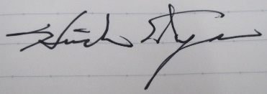
Date : Jan. 14th 2023 Place : Yamagata

Office Use only

Decision | Reason | Signature of authorities | Date
Selected/Rejected

